**SQL**

**What is Database:** Database is a collection of interrelated data.

**What is DBMS:** DBMS (*Database Management System*) is software used to create, manage, and organize databases.

**What is RDBMS?**

* RDBMS (Relational *Database Management System)* - is a DBMS based on the concept of tables (also called relations).
* Data is organized into tables (also known as relations) with rows (records) and columns (attributes).
* Eg - MySQL, PostgreSQL, Oracle etc.

**What is SQL?**

SQL is *Structured Query Language* - used to store, manipulate and retrieve data from RDBMS. (It is not a database, it is a language used to interact with database)

We use SQL for *CRUD* Operations :

* **CREATE** - To create databases, tables, insert tuples in tables et
* **READ** - To read data present in the database.
* **UPDATE** - Modify already inserted data.
* **DELETE** - Delete database, table or specific data point/tuple/row or multiple rows.

**Note** - SQL keywords are NOT case sensitive. Eg: select is the same as SELECT in SQL.

**SQL v/s MySQL**

SQL is a language used to perform CRUD operations in Relational DB, while MySQL is a RDBMS that uses SQL

**Note**: A database can consist of multiple tables.

**SQL Data Types**

In SQL, data types define the kind of data that can be stored in a column or variable. Here are the frequently used SQL data types:

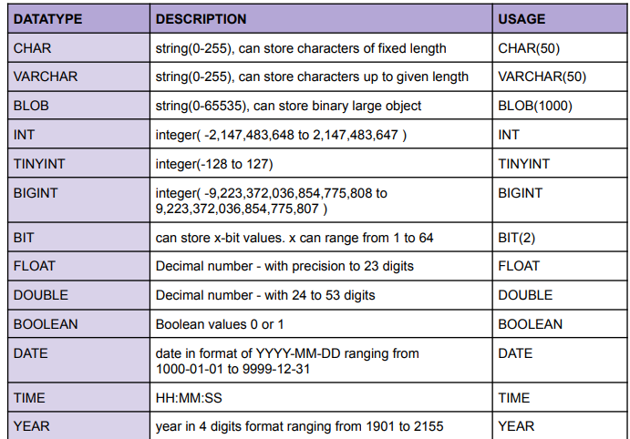

**Difference between CHAR and VARCHAR:**  CHAR occupies all the alloted memory while VARCHAR occupies only the required memory from the alloted memory.

Ex, in char(50) and varchar(50) we store “Chintu” char will occupy all the 50 bytes while varchar will only occupy 6 bytes and remaining bytes can be used to store something else.

**Signed Data type:**  Datatype can store positive and negative values. Ex, **TINYINT** (Range -128 to 127)

**Unsigned Data type:** Datatype can only store positive values.Ex, **UNSIGNED** **TINYINT** (Range 0 to 255) Dekh yaha saara negative ka range positive ko shift kr diya h

**Types of SQL Commands**

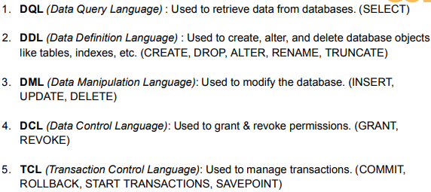

**Creating and Deleting a Database**

**Syntax:** There are 2 ways to create a database

1.

2. here **IF NOT EXISTS** says if the database named **“db_name”** doesn’t exist than create a database named that. Otherwise, don’t.

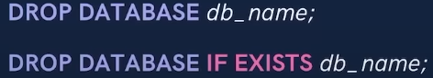

**Syntax:** There are 2 ways of deleting a database

**Use Keyword**

****It says from now on do all the tasks in the specified database.

**Syntax:**

**Eg,**

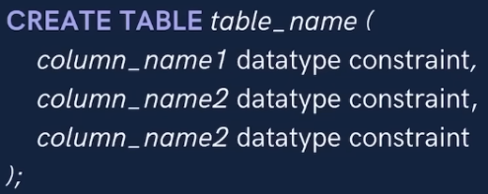**Creating a Table**

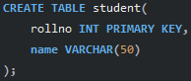Syntax: Ex,

(It’s a table with 3 columns) ( It’s a table with 2 columns. Col 1 and 2 will store rollno and name respectively)

This may seem superficial for now, sb aage clear hoga.

**Viewing a Database and Table**





Here **\*** means all (more about select in pg 6).

**Inserting into a table**

There are 2 ways to Insert in a table

1. **Syntax:** (it’s a syntax of 2 column but we can can create tables with n number of columns.)

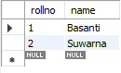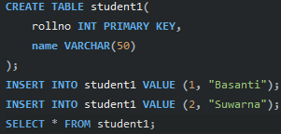Value1 and value2 are the value assigned to the columns .

Eg, Output:

1. **Syntax:**

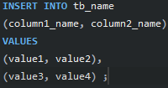Here, it’s a syntax of 2 column but we can can create tables with n number of columns.

Here col1 will store value1 and col2 will store value2 and than again col1 will store value3 and col2 will store value4 and so on.

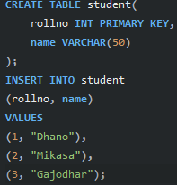

**Eg,**

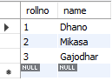 Here a table named student has **2 columns** named **rollno** and **name** which will store below mentioned values.

**Output:**

**So better prefer syntax 2 to store multiple values and syntax 1 for single values.**

**Keys**

**Primary Key:**

For eg, roll_number in a student table, emp_id in a employee table, etc.

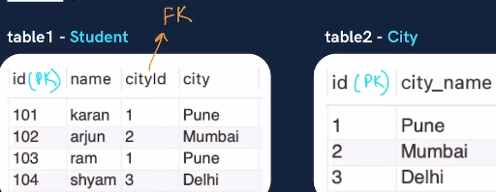**Foreign key: It is a column or set of columns in a table which refers to the primary key another table. There can be multiple foreign keys in a table. It can have null values as well as duplicate values. It establishes the link between 2 tables.**

Eg, In table 1 **cityid** is a **foreign key** because it is using (referring) primary key (here id) of another table (here table2).

It might seem superficial for now aage sb clear hoga while coding.

**Constraints**

It is used to specify a rule or condition for the table.

Few constraints are mentioned below

**1**

**2**

**3** Mtlb if we keep the value empty, by default the specified value will be assigned to the column

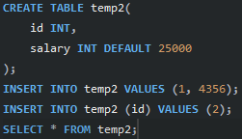Eg, Output:

**4 PRIMARY KEY :** makes a column unique & not null but can be used only once in a table.

There are 2 ways of declaring a column as Primary key.

1. (here id the is the name of the column).



2, (here we have set the contraint to not null we could have kept as empty as well)

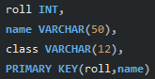We can also set 2 columns are primary key,

Eg, **Here only the combination of roll and name must be unique**. Therefore, we can have same roll but than the name has to different and vice- versa.



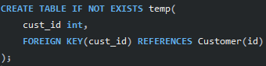**5**

Eg, here, we are saying bhai **cust_id** from temp table please become a Foreign Key and refer from column **id** of another table (as the definition states).

This way we have linked the temp and Customer table too.

**6**

There are 2 ways of using CHECK constraint

1. Eg Now, if we while inserting we must enter age greater than 17 & branch must be equal to INFT otherwise we’ll face error.



1. Eg,

There are many Constraints which we will see ahead.

**Select**

It is used to select and display any specified data or all data from the table

**Basic Syntax**: Here we have selected 2 columns we , can select more or less as required.

**To select and display all columns:**

**To select and display on distinct (unique) values from a Table:**

Here only unique values will be displayed.